6CS027 Secure Mobile Application Development
Workshop 1 - Introduction to Android Studio

Overview
In this and other workshops in this module, you will be learning to build Android apps. However, in order to do this, you will need to work with the Android development tools. The main tool that you will be using is the Android Studio Integrated Development Environment. If you are working on your own computer, you will need to install Android Studio first. There is a video, on Canvas, showing you how to install Android Studio.
For this workshop, you will be using Android Studio to learn how to build a simple Android "Noughts and Crosses" game, in order to familiarise yourself with the environment. Please note that Android Studio like to update itself very frequently, and when it does so, the user interface may change slightly and the screenshots in the workshops may look slightly different depending on which exactly version you might be running.

Part 1 - Starting Android Studio and Creating an Android App
Look for the Android Studio icon  from the Windows Start menu, and start Android Studio.
When Android Studio starts, carry out the following tasks:
- In the Welcome screen, click Create New Project.
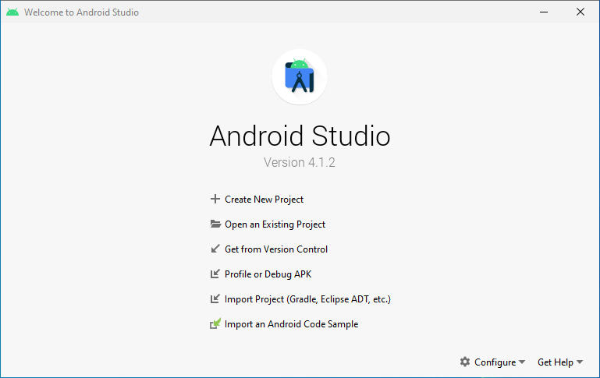
- In the next screen, Select a Project Template, click on Empty Activity, And then Next:
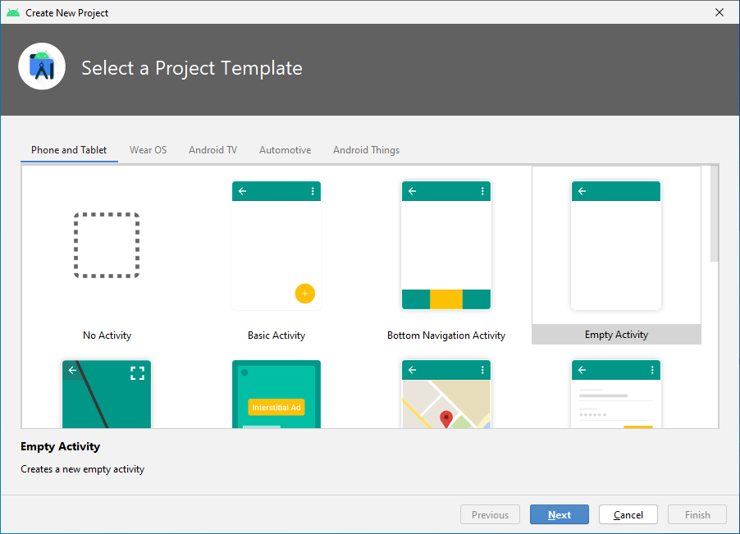

- Under Configure your new project, fill in the fields as shown in figure below: 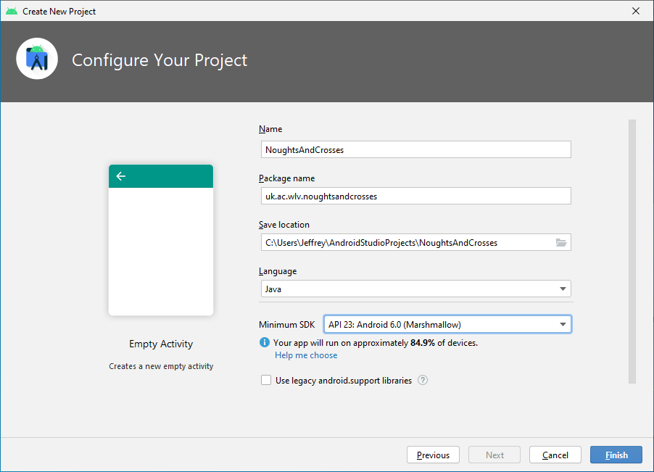
Check your spelling and capitalisation very carefully as they make a difference.
Explanation of the various fields:
  - Name is the app name that appears to users. For this project, use "NoughtsAndCrosses ".
  - Package name is the fully qualified name for the project (following the same rules as those for naming packages in the Java programming language). Your package name must be unique across all packages installed on the Android system. It is the convention to use your organisation's internet domain name to form part of the package name.
  - Save location is the directory on your system that holds the project files. Create a unique directory for this project
- Click the Finish button to create the project. It will then seem to do very little for quite a few minutes. Don't worry, this is normal. You may at first see a blank window for a while, but eventually, you may see something like this:

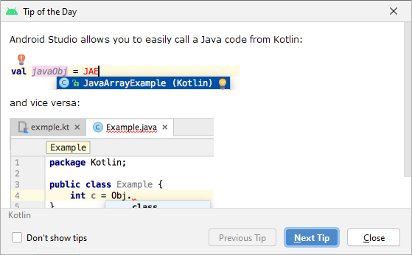
Then, just close the “Tip of the Day” window and wait till you see the following:
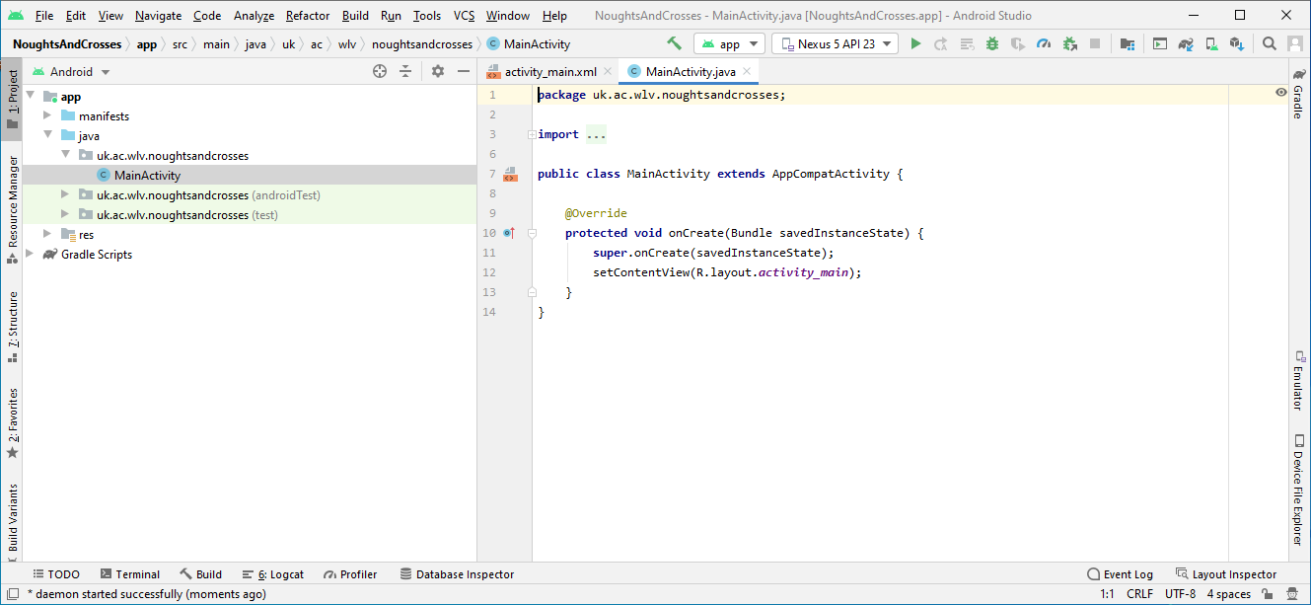
This means that it is now ready and it will have built the basic “Empty Activity” app for you.

Part 2 – Creating an Android Virtual Device
To run your new app, you will now need to set up a virtual Android phone, otherwise known as an Android emulator. You can also use your own Android phone if you have one and have the right USB cable, you can plug it in and turn on the Developer Options on your phone, but we will proceed with just using the emulator for now.
To do this we need to create an Android Virtual Device:
- Go to Tools, Android, then AVD Manager.
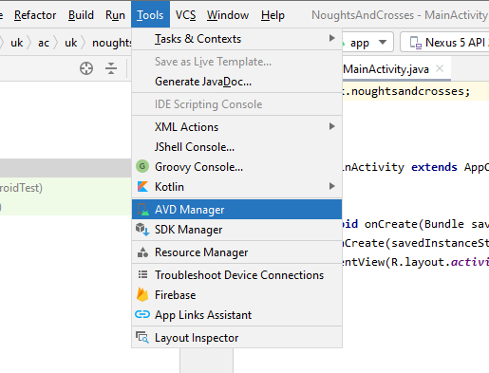
- You will see either this screen if you don't currently have a Virtual Android Device:
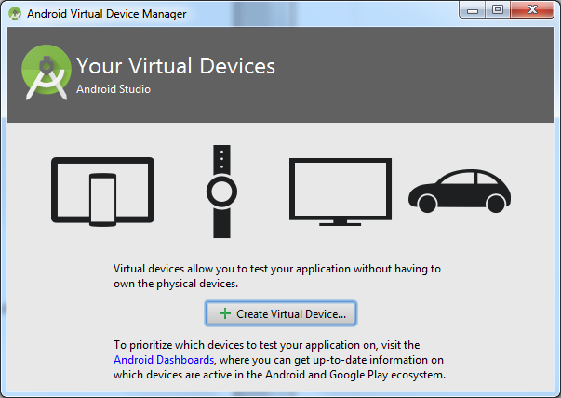
or this screen if you already have one or more Virtual Devices: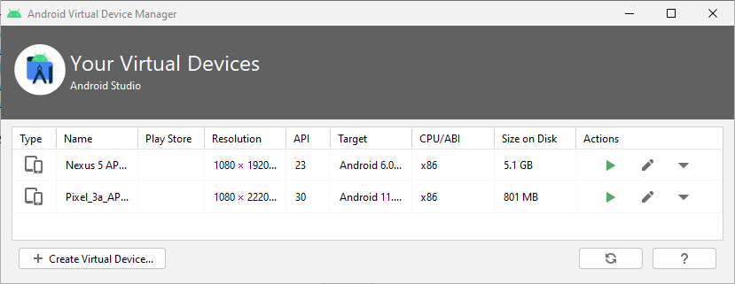
- Click Create Virtual Device, and then on the Select Hardware screen, just click next to select the default choices. This just chooses the size and shape of your virtual phone.
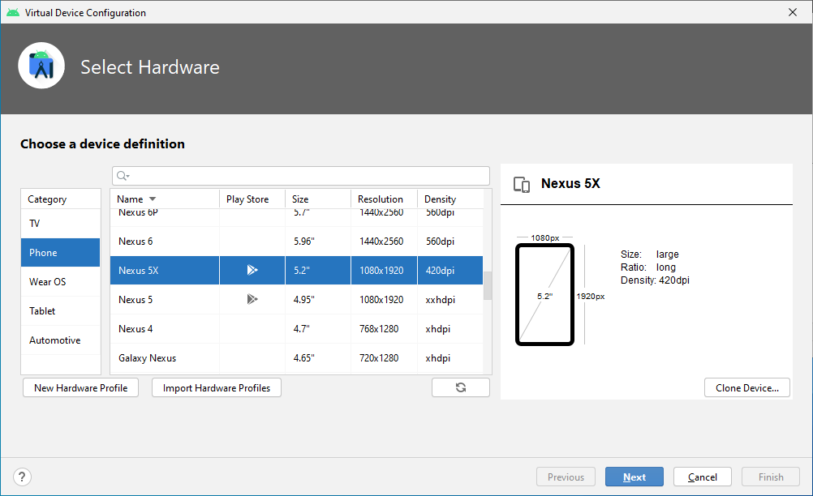
- Choose a Nexus 5X.
- The next screen requires you to choose the version of Android to run this virtual device with. Click on x86 Images
- Download Marshmallow, API Level 23, x86, Android 6.0:
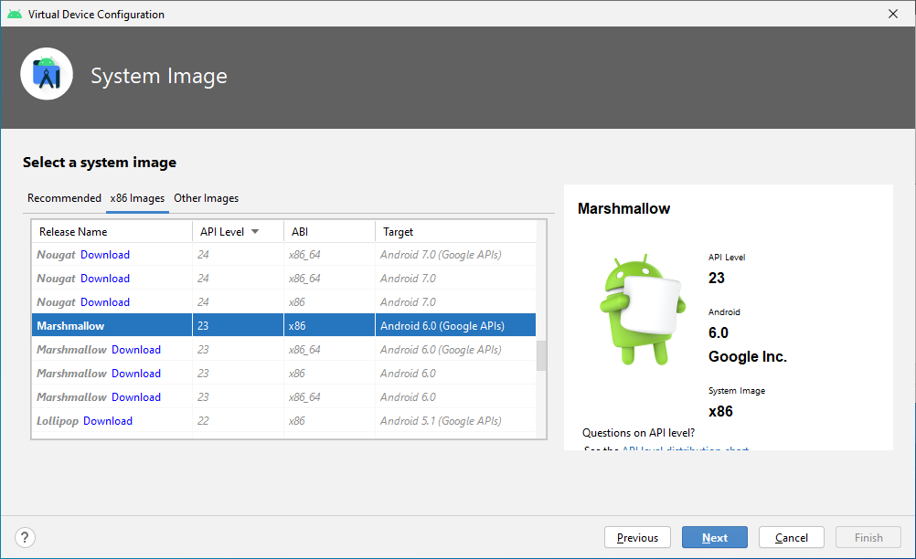
- If it hasn't been downloaded previously, there will be a Download link on the Android 6.0 system image, click it to start the download.
- When it has finished downloading, just click Finish to return to carry on creating the AVD:
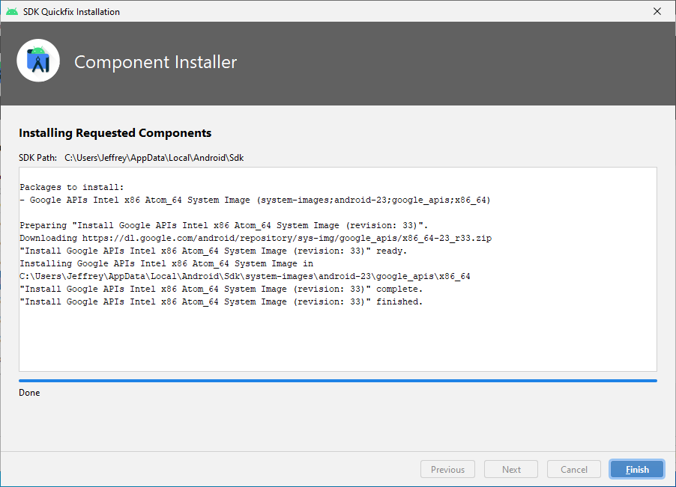
- At the System Image screen, make sure that your just downloaded Android version is selected and then click Next.
- At the Android Virtual Device (AVD) screen, click Next.
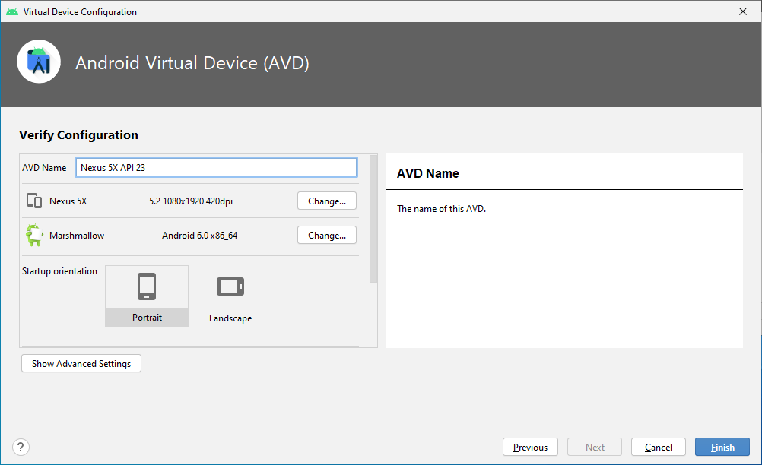
- Then click Finish to create your Android Virtual Device (AVD).
- You will be show the list of AVDs that Android Studio has and it should include the one that you have just created.
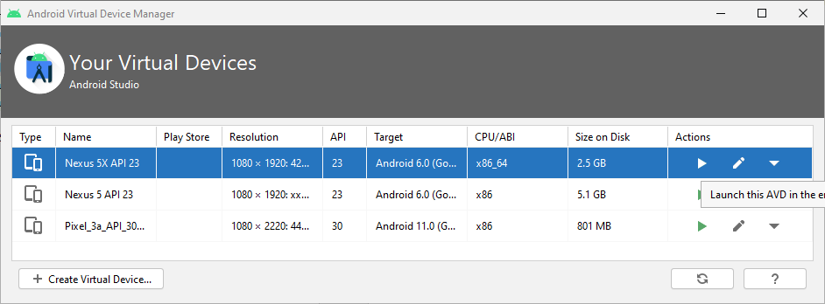
- Click on the triangle Launch AVD button in the top right hand side to start the emulator.
- The emulator will launch and will look like a generic Android phone:
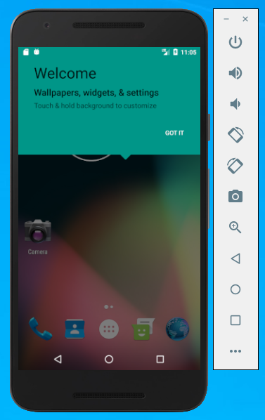
- This part will probably take the longest. The emulator has to load and set up the Android system for the first time, almost like a real brand new phone. Once it is ready, leave it running and go back to Android Studio.

Part 3 - Running the app from Android Studio
- In Android Studio, click he green Run triangle on the tool bar: 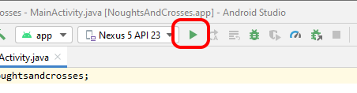
- When running it for the first time, it can take quite a few minutes for the app to load. Eventually, your app will appear on the Android screen:
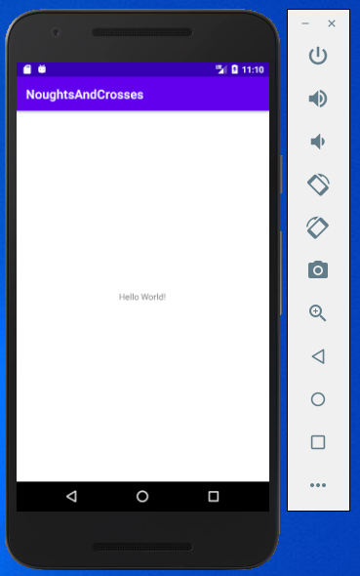
It doesn't do a lot right now, but it is your first Android app, running on a virtual phone.

Part 4 - Building the Nought and Crosses Game

Now we are going to turn our simple do-nothing app into a Noughts and Crosses game. First, we are going to create the User Interface. We are going to keep everything as simple as we can, so we are just going to create 9 buttons and lay them out in a grid of 3 X 3.

This is done in Android Studio by describing the layout in an XML file. This is just a text file describing how the app looks on the phone. This is done in XML rather than programming the layout directly in code is useful for several reasons, so you can create different layouts for different screen sizes. For example, you can create two versions of a layout and tell the system to use one on "small" screens and the other on "large" screens.

Create a Noughts and Crosses Layout
- In Android Studio, find the “res” folder and double click it:
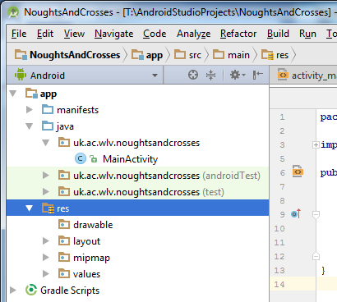
- Then double click the “layout” folder:
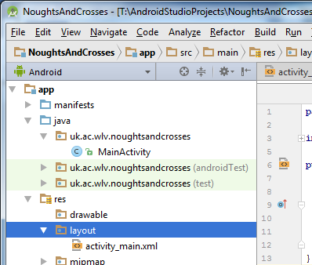
- And then double click the activity_main.xml file:
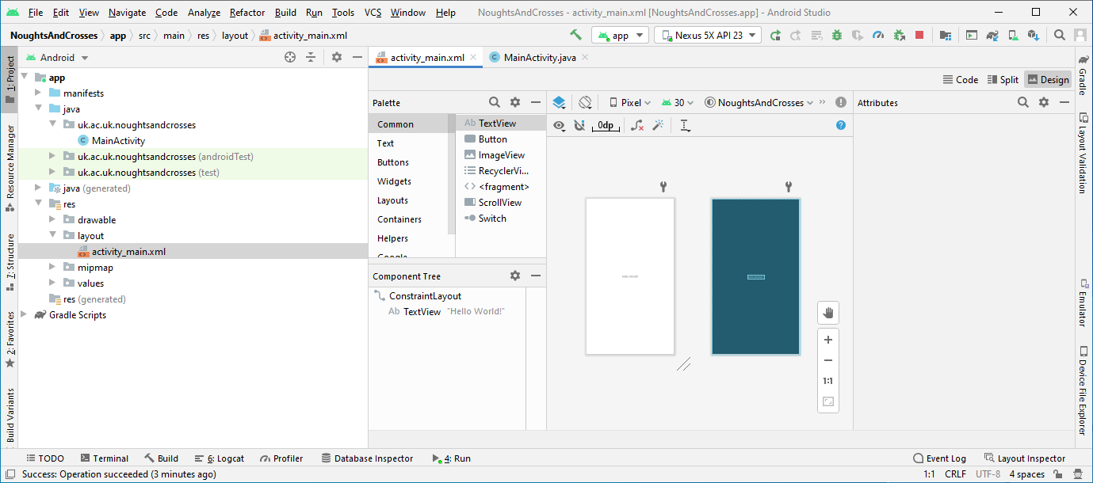
- What you will see is the “layout” that Android Studio has already created for you. We are going to change it by editing it in “Text Mode”.
- Then near the top right of the window, click on the Split tab to switch to the XML text view:
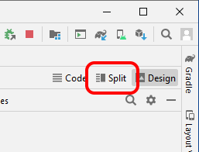
- What you will now see are the text commands in XML format to describe how to show your app on the phone:
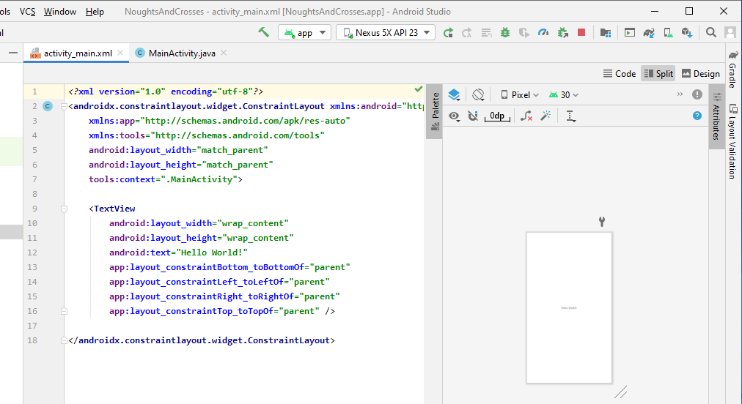
- See if you can spot the original “Hello World!” greeting in there.
- Delete all of the XML code in file, because we are now going to replace it with the new XML layout code below:
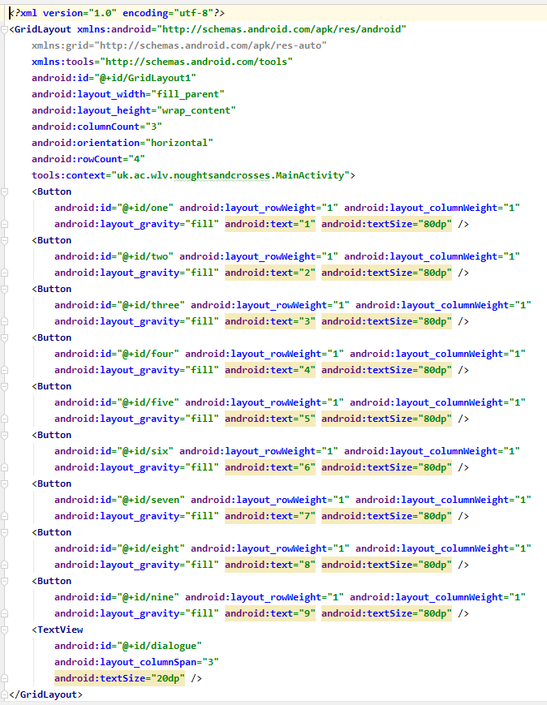
Whilst it looks complex, it is just 9 repeated buttons laid out in a 3 X 3 grid. There is also a text box that we are going to use for messages at the bottom.
- Don't worry about typing it all in. There is a file on Canvas called "activity_main.xml.txt" that contains all of this code. Download and open that file and then copy all of the contents of that file into the activity_main.xml file in Android Studio to create your new layout.
- Now to see how this looks like, run your app in the Android emulator by click on the menu item "Run" and then "Run app":
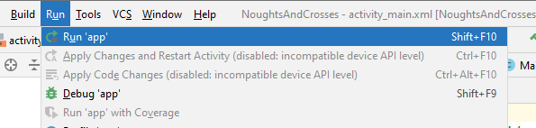
- If that worked, the Android emulator would fire up and show you something like this:
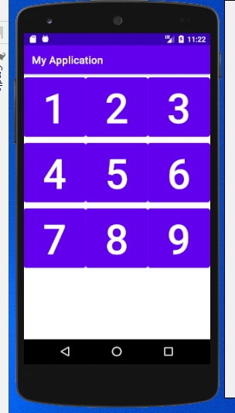
- Now, some people might like this, but I am personally not too keen on this default "Google Material Design" look.
- Find the file called themes.xml in your Android project and open it:
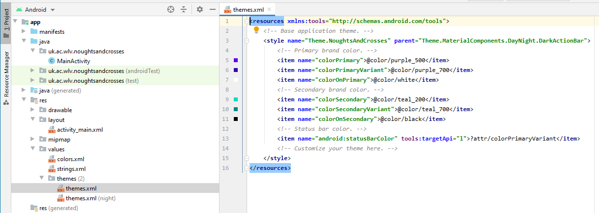
- Find the word "MaterialComponents" and change it to "AppCompat" :
- Now click the "restart" button on the toolbar:
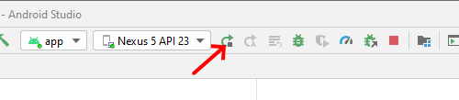
- Your app should now look a bit more like this:
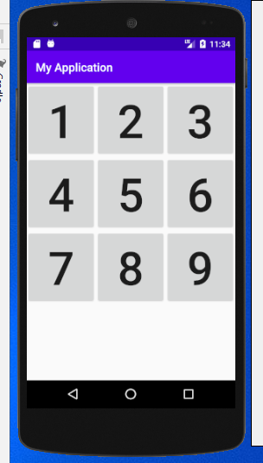
Perhaps a bit less "stylish" but easier on the eye and simpler.
Create the Noughts and Crosses Game Code
Now for the turn of the game code itself.
- In Android Studio, and then double click on the MainActivity file:
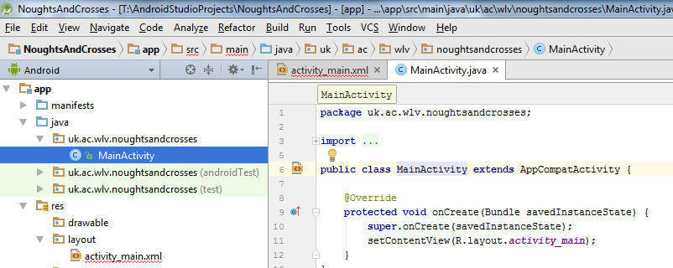
- Replace the original Java code that is currently there, with the code that is in the file "MainActivity.java.txt" on Canvas, in a similar manner to what you did with the XML code.
- Android Studio normally compiles the code as soon as you change it, but in case it is not in sync, make sure it is by "Cleaning" the project by clicking on Build and Clean Project:
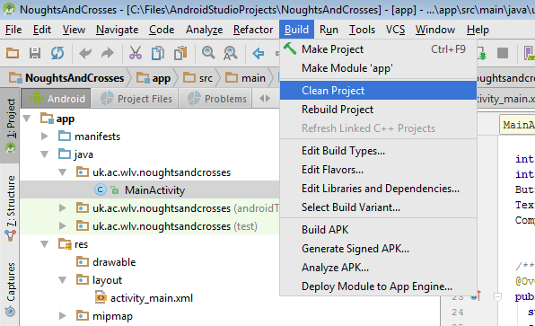
- Hopefully Android Studio will rebuild the code automatically without errors.
- Click Run, and then Run App, and the Noughts and Crosses app should run in your Android Virtual Device.
- Play a few games and see how often you can beat it. When you finish a game, you can restart it by clicking 3 dots on the top right of the Android phone:
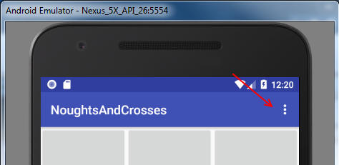 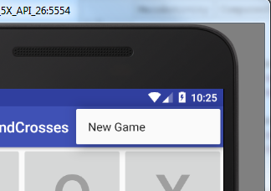
Part 5 - Examining the Code
Now let's have a look at the App's code to see how and where it does what it is doing.
Preliminaries
With Android apps, as with all Java programs, if there are more than one class, the "package" concept allows the different classes to group together under one collection(package) and be able to call each other's methods. We also need to import all the classes provided by Android environment that we are going to be using in our app so that the Java compiler can check whether we are using them correctly. In this case, at the top of our MainActivity.java file, we have :
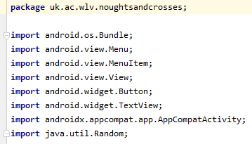
The package name uk.ac.wlv.noughtsandcrosses is what we specified at the beginning when we created the project. We will try to keep to the format of " uk.ac.wlv.appname" for all of our Android work. This avoids potential clashes with external libraries and so on.
The "imports" section is mostly self-explanatory with the User Interface (UI) elements such as the menu, button and text view (text box). The "Bundle" is just a name for the Android app memory storage mechanism for when an app is suspended or go to sleep. We also use a random number method to generate some of our moves and hence we needed the Random utility.
The Main Class
The android app is mostly defined by the class definition:

We could have called our main application class just about anything else other than "MainActivity", but this is accepted convention within Android development, and indicates that this is the code that runs first when it starts. Thus we should stick to the convention whenever possible.
Our MainActivity class is derived from an Android system class called "AppCompatActivity". In some references, particularly older ones on the internet, you will see in their examples that their app class would extend from a system class called "Activity" instead of AppCompatActivity. There are no significant differences between them except that the AppCompatActivity is a more recent addition that provides more flexibility in adapting to different ages of Android phones, from the latest to the oldest.
Within the main class the code starts off with the following:
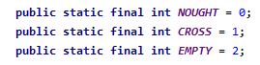
These are just labels that we are using within the rest of the code to avoid using "magic" numbers that don't appear to mean anything. They are values stored with the gameboard array to keep track of the current state of the game. Then we have :
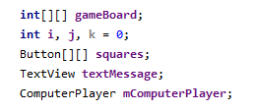
The gameboard array represents the noughts and crosses board. The I, j, and k variables are generic variables use for various for loops in the code. The squares array holds references to the user interface buttons that allows the user to click on them on the board. The textMessage variable holds the text that is show to the user, and the mComputerPlayer variable is just a convenient class object that collects together all the code that is relevant to the game logic.
When the program starts, it will call the following method:
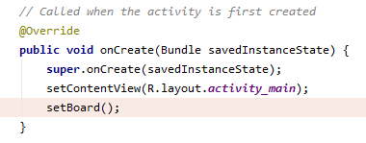

The first line, super.onCreate(savedInstanceState) allows the Android system to restore any saved information if the app was previous put to sleep(suspended). The second line setContentView(R.layout.activity_main) displays the user interface; in our case the noughts and crosses board. The third line setBoard() initialises the game arrays and variables to their initial states.
Next the app would then call the method:
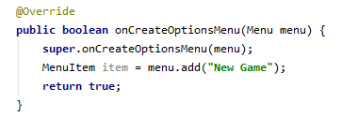
which sets up the "New Game" menu on the top right. When you click o the "New Game" menu, the following method is called:
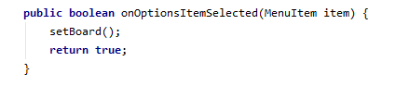
which just reinitialises the game variables back to the initial state by calling the setBoard() method below: 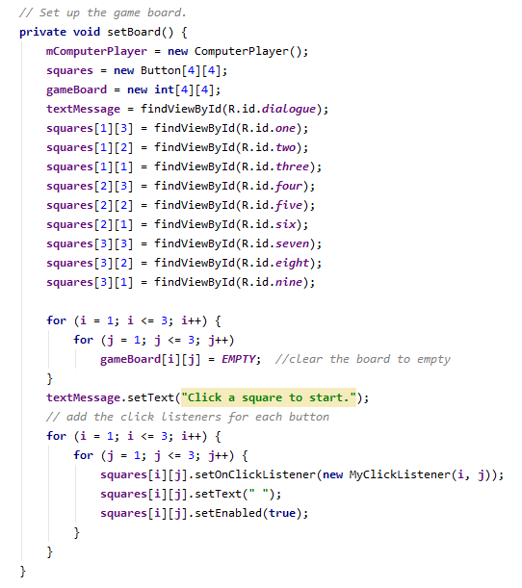
The method starts by initialising the variables mComputerPlayer, squares, and gameboard. Then it connects the textMessage variable and the squares to the corresponding user interface text box and buttons. Next it clears the gameboard by setting all elements of the array to "EMPTY". The " Click a square to start." is then displayed.
When the user click on a "button", a method needs to be called to deal with the click. In this case, we do this by using the class MyClickListener to identify and handle the user clicks for each button, set the button display to blank and then we "enable" each button.
The next method checkboard() is the heart of the program. It is called after each move to check if either player has won.
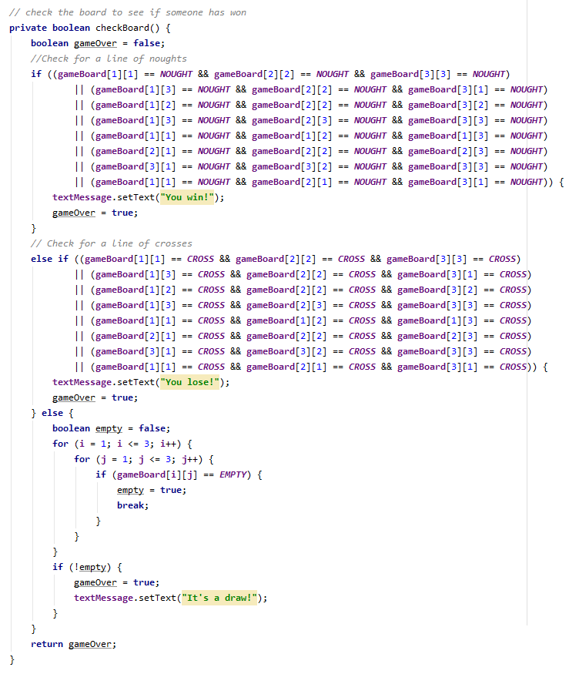

The checks themselves are fairly straightforward: The "if" statements first checks every row , column and diagonal for a line of noughts and if there is, declares the user as the winner, and then if not, checks the board again for a line of crosses, and declares that the user has lost. Then if neither side has won, it checks to see if there are still empty squares left. If not, it declares the game as a draw.
The next part of the code is a simple class that handle the button clicks:
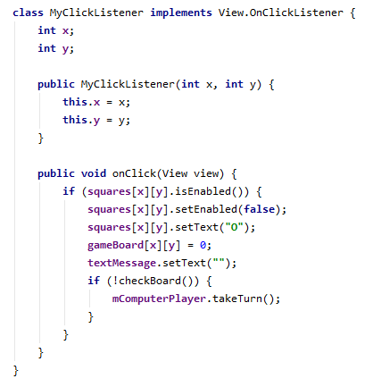
When the user clicks on a square, it displays a "nought" on the square and sets it to be "disabled" so that the user cannot click it again. Then it call checkboard() to check whether the user has won with that move; if not, calls mComputerPlayer.takeTurn() to let the program make the next move.
When it is the program's turn to make a move, the takeTurn() method first checks to see if it can block a possible user win on the next turn, if not, it just makes a random move:
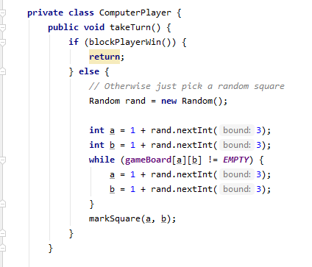
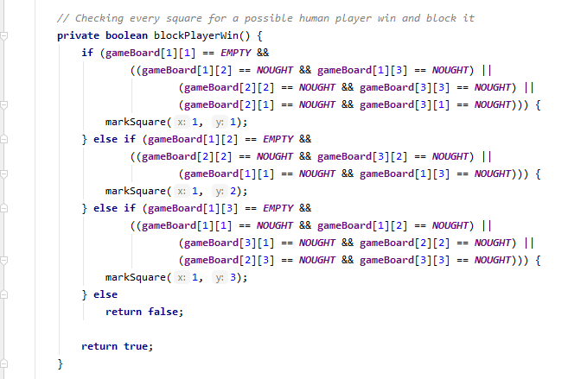
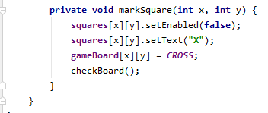
In the method blockPlayerWin(), it checks every line for the existence of two noughts and an empty space. This would mean that the user will be able to win on the next move. If this finds this, it will then take that square by calling the method markSquare(), hopefully blocking the winning move.

Part 6 - Improving the program
As it stands, the program doesn't actually play a very clever game of noughts and crosses. The only thing that approximates a gameplay strategy is the method called blockPlayerWin() which is called by the method takeTurn() after the human player clicks. All this method does is to try and block a possible player winning move. There is no strategy for the program to even attempt to win. Let make a start to see if we can improve on this.
Just after the blockPlayerWin() method add a method called canComputerWin() as shown below:

// Checking every square for a possible human player win and block it
private boolean blockPlayerWin() {
. . .
return true;
}
private boolean canComputerWin() {
return true;
}
At the moment it doesn't do a lot, but it is just a place holder for your code. We will add code later to try and improve the gameplay. In the meantime we need to modify the takeTurn() code to call this new method. Change the takeTurn() method to the following code:
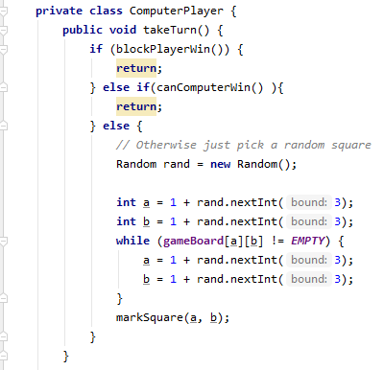
So now on every turn, it first checks to see if it can block a possible user winning move, if not it will call canComputerWin() to try and win. Now change the canComputerWin() method to the following:
private boolean canComputerWin() {
if(gameBoard[1][1]==EMPTY && gameBoard[1][2] == CROSS && gameBoard[1][3] == CROSS) {
markSquare(1,1);
return true;
} else if(gameBoard[1][1]==EMPTY && gameBoard[2][2] == CROSS && gameBoard[3][3] == CROSS) {
markSquare(1,1);
return true;
} else {
return false;
}
}

The added "if ... else" code first checks to see if the top left square is empty and the remaining squares on the first line have crosses. If so, it takes the empty square to win. If not, it then checks the first diagonal line for the same condition and take the winning square if it is there. Otherwise the method returns "false" to indicate that there is no winning position.

Additional Challenge
As it stands, the code above only checks for the top left square being empty and the top row and the first diagonal for a possible win. Now your task is to extend the canComputerWin() method so that it checks for every possibility of a program win on the next move.
There is another simple trick you can do to increase the game performance. At the moment, the code in takeTurn() checks if it can block a player win first and then goes on to see if it can make a winning move. If you were to swap the order around so that it check to see if it can win first, maybe it might win more often.
With checking for winning moves, we are only checking for winning at the end stage of the game. The in-between moves are still random. There are good general strategic moves like taking centre square and the corner squares during the game that will help tremendously. Consider implementing something like that.

